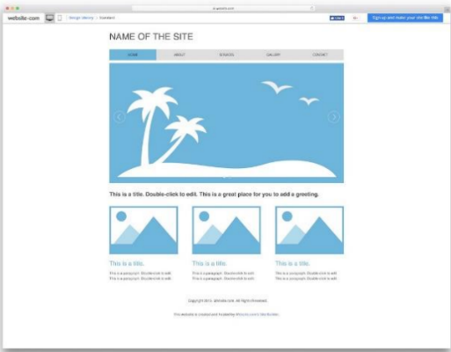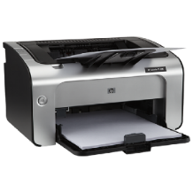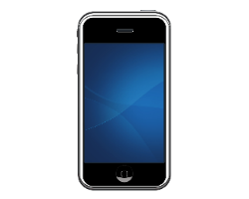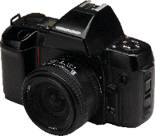

A paragraph could be part of a text that informs people, describes something, critiques something, compares things, persuades people, lists a process, makes an argument, offers a solution or narrates a story. And, the level of detail will vary from text to text.

ll this diversity means that it's not always easy to determine what "one topic" means when dividing your text into paragraphs. For example, you could have a one-topic paragraph describing Venus (with the next paragraph).

Welcoming visitors is an excellent way of improving user experience (UX). It can set the tone for the

rest of their visit on your site.

The right welcome message can be the first step to gaining a lifelong fan or customer. That’s why, in

today’s post, we’ll look at 11 website welcome message examples that you can use on your own site.

Welcome to website

Read more

a printer is a peripheral which makes a persistent human-readable representation of graphics or text on paper or similar physical media.

Read more

Whether you're a mobile-tech expert, novice or somewhere in between, Verizon has a wide selection of smartphones. Find the perfect smartphone for you

A small camera with a permanently attached lens, a point-and-shoot model doesn’t allow manual control of key settings like shutter speed, aperture and ISO sensitivity.

Read more

Product 3

Product 2

Product 1

Produce

**Home**

Services

Gallery

Company

Contact

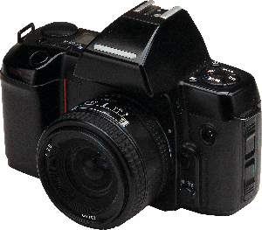

A camera is an optical instrument for recording or capturing images, which may be stored locally, transmitted to another location, or both.

A camera is an optical instrument for recording or capturing images, which may be stored locally, transmitted to another location, or both.

**Product 3**

Read more